PHP FULL STACK ASSIGNMENT

Module 1- Overview of IT Industry:--------

Q1. Write a simple "Hello World" program in two different programming languages of your choice. Compare the structure and syntax.

* Php:- echo “hello world”;
* Python :- print (“hello world”);
* C:- #include<stdio.h>

Void main()

{

printf(“hello world”);

retrun 0;

}

Q2. Research and create a diagram of how data is transmitted from a client to a server over the internet.

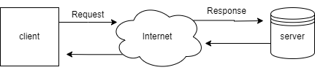

Q3. Design a simple HTTP client-server communication in any language.

Q4. Research different types of internet connections (e.g., broadband, fiber,

satellite) and list their pros and cons.

* 1. Broad Band:- (cable Internet): Broad Band internet is a high – speed internet connection that comes through your telephone line or cable TV line.

It is most commonly used in homes and office.

Props:- -easy to setup , available in most areas and widely used , it is less costly

Cons:- - in this speed is decrease if many people is use the internet same time , it is slower than fiber cable.

* 2. Fiber Optic Internet : This is uses very thin glass or plastic wires to send data using light signals. This makes it extremely fast and reliable.

Props:- - It has very fast internet speed for downloading or streaming, if many people are using the same internet than the speed is stay good, it is easy to set up and maintain .

Cons:- - it has high setup cost, it has limited availability means not available in all cities and rural areas

* 3. Satellite Internet : It is a type of internet connection that uses satellites in space to send and receive data.

Pros:- - It provide internet in anywhere where cables don’t reach, for getting internet no cables needed

Cons :- Doesn't work well during bad weather, More expensive, Slower than other types

* 4. Mobile Data:- Mobile data uses mobile networks through your SIM card to give internet on phones, hotspots, or dongles.

Pros:- - you can use it anywhere like home ,out side ,while traveling ,

It provide fast speed through 4G, 5G,

No wires are needed .

Cons: - limited data plan usually comes with daily or monthly data ,

Q5. Simulate HTTP and FTP requests using command line tools (e.g., curl).

* Curl : curl is a tool we use in the command line like “cmd” to talk to the servers on the internet.

1.HTTP Request : curl <http://example.com> , “This command opens a website and show the content in the terminal”.

2.FTP Request :

Q6. Identify and explain three common application security vulnerabilities. Suggest possible solutions.

* 1. Public Wi-Fi Risk :-

Using free Wi-Fi in cafes , malls , or stations can be dangerous. Hackers can see what you are doing online.

Solutions : during public wifi don’t use banking applications and don’t share personal information through public wifi.

* 2.App permission misuse :-

When we are downloads application and install it on our device than it ask for a permission like access to contacts , camera, or location , even if the application does not need them.

Solutions :- check app permission in phone setting and uncheck the unnecessary permissions,

Download application from the safe websites or play stores.

Q7. Identify and classify 5 applications you use daily as either system software or application software.

* .

|  |  |  |
| --- | --- | --- |
| **Application Name** | **Type of Software** | **Use** |
| **Google Chrome** | Application Software | Used for searching information , play online games , watch movies , etc. |
| **WhatsApp** | Application Software | Used for chating and send messages, documents etc. |
| **File Explorer** | System Software | This is the main software that tuns on the laptop |
| **MS Word** | Application Software | This software is used for create and edit the documents |
|  |  |  |

|  |  |  |
| --- | --- | --- |

Q8. Design a basic three-tier software architecture diagram for a web application.

* 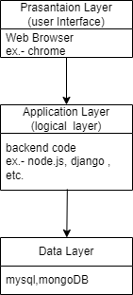

Q9. Explore different types of software environments (development, testing, production). Set up a basic environment in a virtual machine.

* 1. Development Environment:_

Used by a programmers for writing and building the application, programmer use tools like code editor for example vscode, notepad , etc.

2. Testing Environment:

Used By a Tester for finding bugs and errors from the software , Tester use tools like Testing tools .

3. Production Environment :

Used by end users for show the final output and flow of the application,

End user use tool like web server, databases and monitoring tools.

Q10. : Write and upload your first source code file to Github.

* 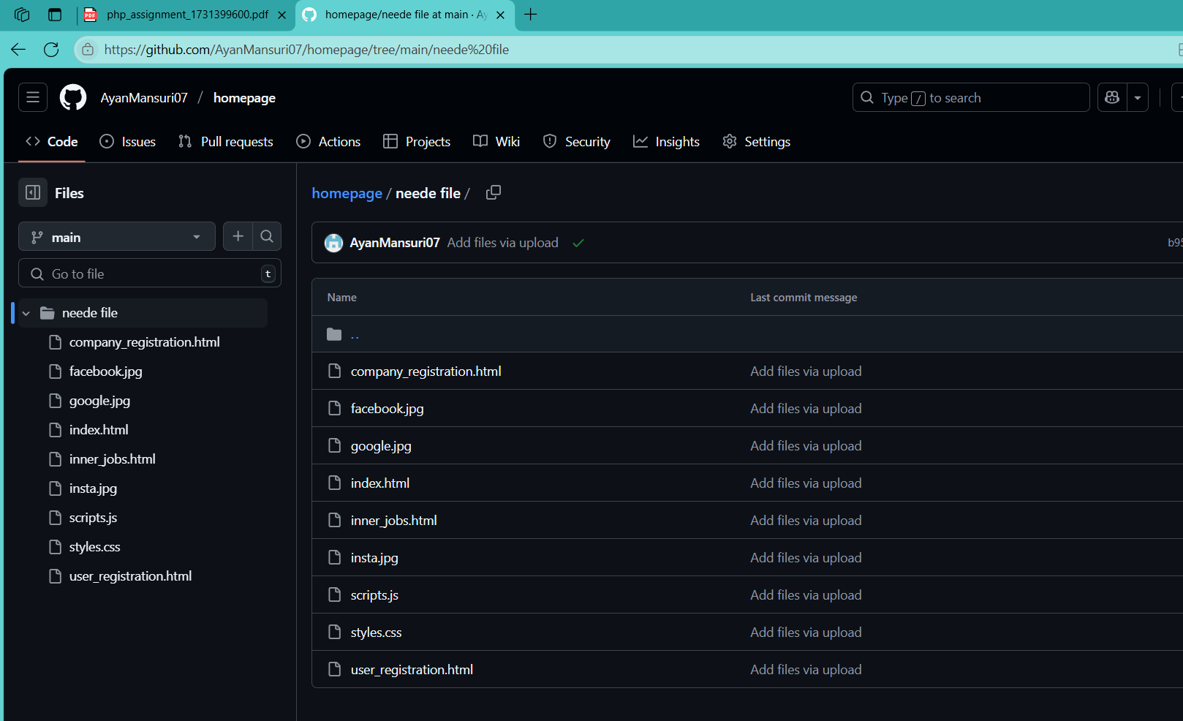.

Q11. Create a Github repository and document how to commit and push code changes.

* 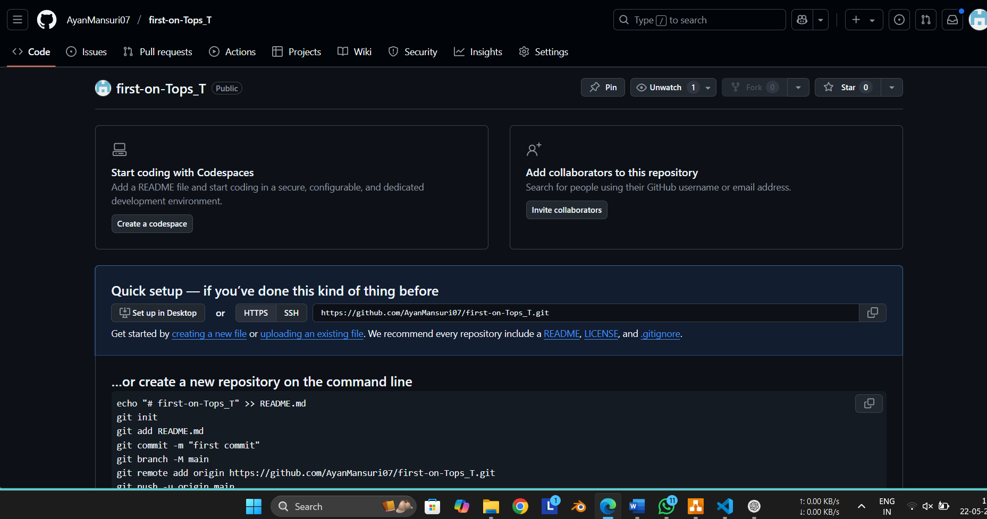.

Q12. Create a student account on Github and collaborate on a small project with a classmate.

* 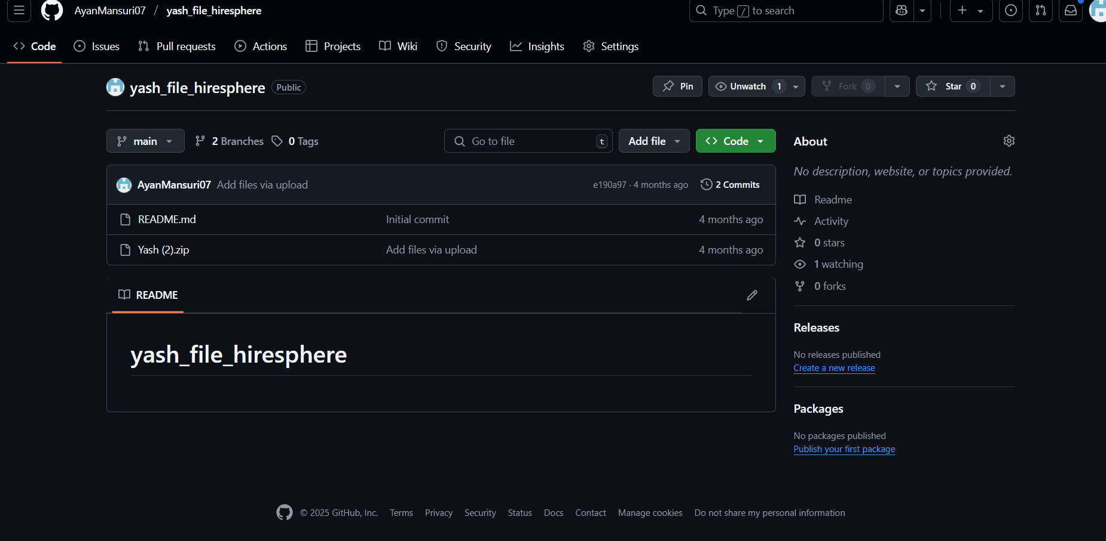.

Q13. : Create a list of software you use regularly and classify them into the following categories: system, application, and utility software.

* .

1. System Software : windows 11,linux , macOS
2. Application Software : chrome, zoom, word, excel, blender, vscode
3. Utility Software: windows Defender, Task Manager, Win RAR

Q14. Follow a GIT tutorial to practice cloning, branching, and merging repositories.

* . I Don’t Know

Q15. Write a report on the various types of application software and how they improve productivity.

* . I don’t know

Q16. : Create a flowchart representing the Software Development Life Cycle (SDLC).

* .

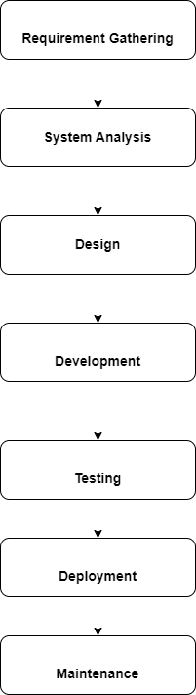

Q17.: Write a requirement specification for a simple library management system.

* .
* • The system allow users register and log in.
* • It should allow adding, searching, and updating books.
* • managing the membership and user queries.
* • Managing the digital books .
* • Only authorized people can change book details to keep data safe

Q18. Perform a functional analysis for an online shopping system.

* **. User Registration & Login -> Browse & Search Products -> Add to Shopping Cart ->**

**Place Order -> Process Payment -> Order Confirmation & Notification ->**

**Order Tracking by User -> Admin Product & User Management.**

**Q19. Design a basic system architecture for a food delivery app.**

* **.**

**User signs into their account**

**User browses available restaurants and menu items.**

**User places a food order.**

**User chooses a payment option.**

**Restaurant gets notified about the new order.**

**User monitors the order status**

**Delivery person picks up and delivers**

**After receiving the order, the user can provide a review or rating.**

**Q20. Develop test cases for a simple calculator program.**

* **.**

**#include <stdio.h>**

**int main() {**

**char op;**

**float num1, num2, result;**

**printf("Enter an operator (+, -, *, /): ");**

**scanf(" %c", &op);**

**printf("Enter two numbers: ");**

**scanf("%f %f", &num1, &num2);**

**switch(op) {**

**case '+':**

**result = num1 + num2;**

**printf("Result: %.2f\n", result);**

**break;**

**case '-':**

**result = num1 - num2;**

**printf("Result: %.2f\n", result);**

**break;**

**case '*':**

**result = num1 * num2;**

**printf("Result: %.2f\n", result);**

**break;**

**case '/':**

**if (num2 != 0) {**

**result = num1 / num2;**

**printf("Result: %.2f\n", result);**

**} else {**

**printf("Error: Division by zero!\n");**

**}**

**break;**

**default:**

**printf("Invalid operator.\n");**

**}**

**return 0;**

**}**

**Q21.** D**ocument a real-world case where a software application required critical maintenance.**

* **. I don’t know**

**Q22. Create a DFD for a hospital management system.**

* **.**

**Q23. Build a simple desktop calculator application using a GUI library.**

* **. I don’t know**

**Q24. Draw a flowchart representing the logic of a basic online registration system.**

* **.**

